User Interfaces

**Registration Page**

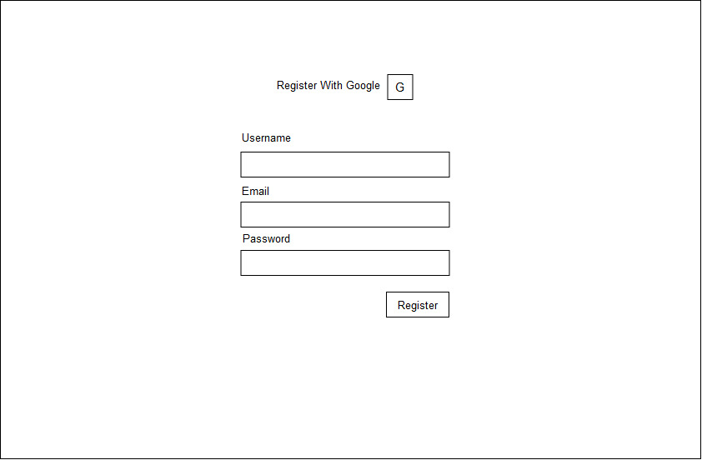

#### Login Page

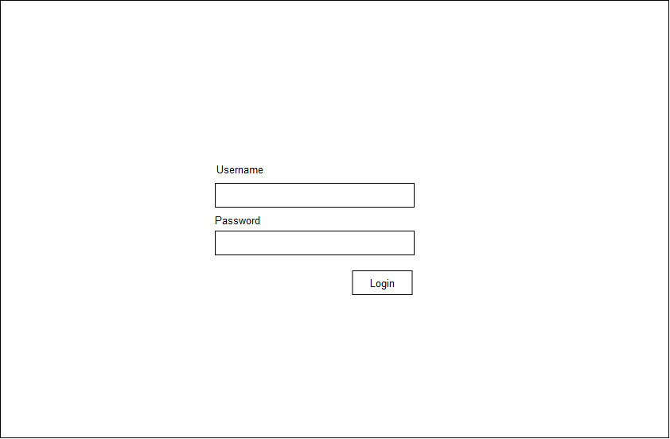

**Search Result Page**

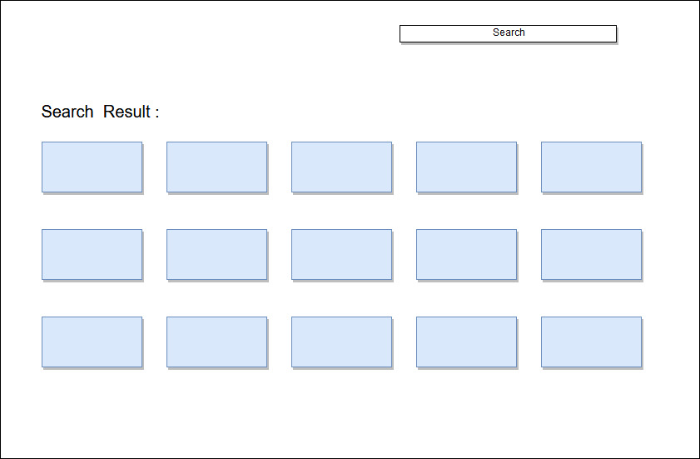

#### Watch-list Page

#### C:\Users\User\AppData\Local\Temp\Rar$EXa1648.47674\nabeel_mohammed-nsu.nbm.summer2019.cse327.2.t3-7688be43e8ce\SRS\images\Watchlist.jpg

#### Recommendation Page

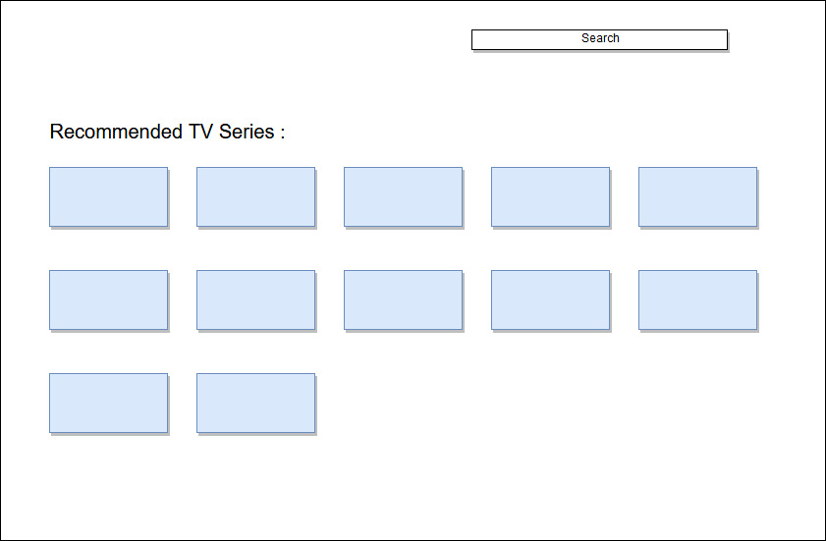

#### Trending Page

